**Week#6**

**Understanding DHCP**

**1.`Learning objectives:**

* Learn **Dynamic Host Configuration Protocol** in detail.
* Know how different systems get IP addresses

**This session has 2 parts**

**1.Test network using one DHCP server**

**2. Test network using 2 DHCP servers**

**2 Network with one DHCP Server**

Set up the network as follows

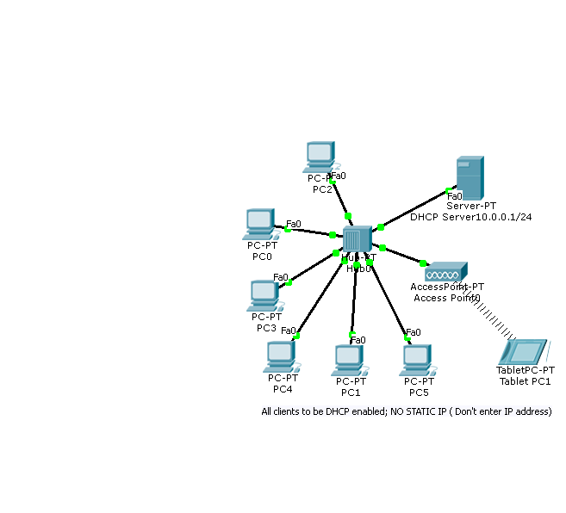

**2.1 Test DHCP in Real Time Mode**

|  |  |  |  |
| --- | --- | --- | --- |
|  | **Do** | **observe** | Answer |
| 1 | **Select Real time mode** |  |  |
| **2** | **Set up DHCP server** |  |  |
|  | Click on Server |  |  |
|  | Select Config |  |  |
|  | Click **DHCP** |  |  |
|  | Set Service **ON** |  |  |
|  | Enter the following data |  |  |
|  | Default Gateway : 0.0.0.0 |  |  |
|  | DNS Server : 0.0.0.0 |  |  |
|  | Start IP address : 10.10.10.1  Subnet Mask : 255.255.255.0 |  |  |
|  | Maximum Number users : 8 |  |  |
|  | Click Save |  |  |
| **3** | **Set IP address for DHCP Server** |  |  |
|  | Select ‘Fast Ethernet’ |  |  |
|  | Enter IP address : 10.10.10.1  Subnet Mask : 255.255.255.0  Port Status On |  |  |
| 4 | **Set each client PC as DHCP client**  **[ No need to set any IP address ]** |  |  |
|  | Click PC |  |  |
|  | Select Config |  |  |
|  | Select Settings |  |  |
|  | Select DHCP |  |  |
| 5 | **See DHCP in action** |  |  |
|  | Click PC0 | Client acquires IP address from DHCP server | Write down IP address acquired  **Ans :** |
|  | Click PC1 | Client acquires IP address from DHCP server | Write down IP address acquired  **Ans :** |
|  | Click PC2 | Client acquires IP address from DHCP server | Write down IP address acquired  **Ans :** |

**2.2. Analyse 4 steps (Discovery,Offer,Request,Acknowledgement) of DHCP in Simulation mode**

|  |  |  |  |
| --- | --- | --- | --- |
|  | **Do** | **observe** | Answer |
| 1 | **Select Simulation mode** |  |  |
|  | **Click Power Cycle devices** |  |  |
|  | Click PC0 |  |  |
|  | Click Auto Capture / Play |  |  |
|  | Wait until DHCP is complete |  |  |
|  |  | Event list ( **Filter all other protocols except DHCP**) |  |
|  |  | DHCP Discovery PDU | Write down   1. CLIENT ADDRESS   **Ans :**   1. ‘YOUR’ CLIENT ADRESS   **Ans :**   1. SERVER ADDRESS   **Ans :** |
|  |  | DHCP Offer PDU | Write down   1. CLIENT ADDRESS   **Ans :**   1. ‘YOUR’ CLIENT ADRESS   **Ans :** |
|  |  | DHCP Request PDU | Write down   1. CLIENT ADDRESS   **Ans :**   1. ‘YOUR’ CLIENT ADRESS   **Ans :** |
|  |  | DHCP Acknowledgement PDU | Write down   1. CLIENT ADDRESS   **Ans :**   1. ‘YOUR’ CLIENT ADRESS   **Ans :** |

**3. Network with two DHCP Servers**

**Add one more DHCP server as shown below.**

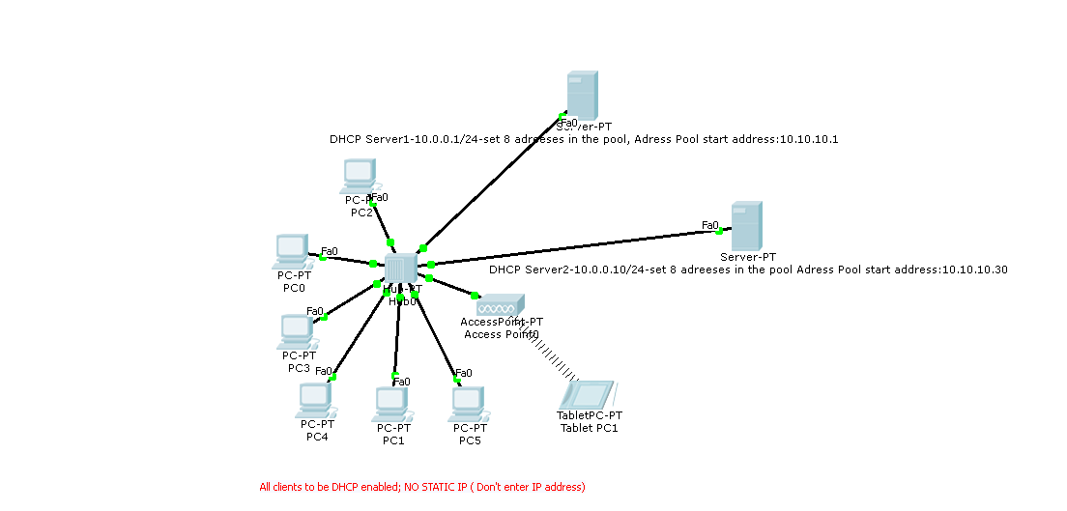

**[ Use Real time mode only. Click ‘Power cycle devices’ whenever you want start afresh.]**

**3.1. Normal operation with sufficient IP addresses in the pool.**

Configure parameters as shown in the diagram. ***Observe how Clients acquire IP addresses from both the servers***

**3.2. Restricted IP address pool**

Start afresh.

In the DHCP Sever1- restrict the number of users to 2.

In the DHCP Sever2- restrict the number of users to 4.

Observe that all PCs can not get IP addresses from DHCP.

**Homework :**

**Add a router to the set up shown in 2, move DHCP server behind the router. Check whether it works or not. Why or why not ?**